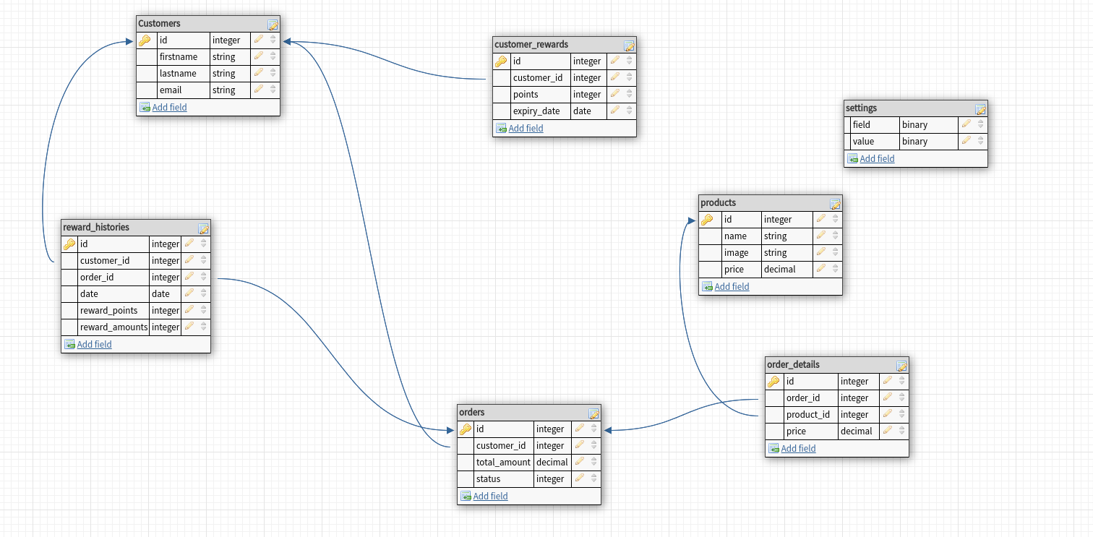**Here is the answer of question 1.2**

MySQL database schema for this reward system

Here :-

1. customer_rewards table is used to store the updated rewards after every sales order completion.
2. reward_histories is introduced to store the history of reward uses , it stores for which customer the reward is used and for which order and when it was used.
3. settings table is introduced to store the settings from admin section :-
   1. for this system we can store dynamic value of the conversion , eg:- for now the 1point = 0.01$ , admin can change this value if necessary .for that [ ‘f’ield’ => ‘reward_point’ ,’value’ => 0.01]

Also the mysql is exported in the file

**Question1.2 db schema.sql**